Ideation Phase
Define the Problem Statements
Date | 15 February 2026
Team ID | LTVIP2026TMIDS66413
Project Name | Automated car catalog system for enhanced
Maximum Marks | 2 Marks

Customer Problem Statement Template:
Create a problem statement to understand your customer's point of view. The Customer Problem Statement template helps you focus on what matters to create experiences people will love.
A well-articulated customer problem statement allows you and your team to find the ideal solution for the challenges your customers face. Throughout the process, you’ll also be able to empathize with your customers, which helps you better understand how they perceive your product or service.
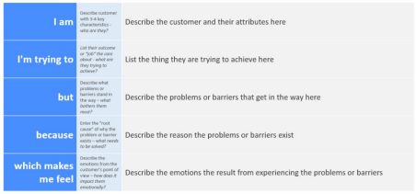Reference: https://miro.com/templates/customer-problem-statement/ Problem Background
Modern organizations manage thousands of users across multiple systems. Traditional manual user and permission management leads to:
• Security vulnerabilities
• Human errors
• Delayed access provisioning
• Poor audit compliance
• Difficulty in scaling
Problem Statement
Organizations face significant challenges in efficiently managing users, groups, and roles across systems. Existing solutions often lack automation, centralized control, and proper workflow mechanisms, resulting in security risks, administrative overhead, and inefficient access governance.
Therefore, there is a need to design and implement an optimized system that: • Automates user lifecycle management
• Provides robust role-based access control
• Enables workflow-driven approvals
• Ensures auditability and compliance
• Improves scalability and security

